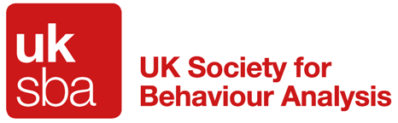

To whom it may concern,

RE: Professional Standards Authority Accreditation

We are writing to make you aware of the UK Society for Behaviour Analysis (UK-SBA). The UK-SBA maintains a register of qualified professionals working as behaviour analysts that have additional insurance, disclosure and safeguarding checks to meet criteria for membership. The UK-SBA register has now been accredited by the Professional Standards Authority (PSA). Professionals on the UK-SBA voluntary register who work in the field of health and social care (and education) are now accredited by the PSA. All professionals on the
UK-SBA voluntary register have agreed to follow the UK-SBA Ethical and Professional Code of Conduct and have signed up to the UK-SBA Complaints Procedure.

Those UK-SBA members who work in the field of Health and Social Care (including education), are eligible to use the PSA Quality Mark:

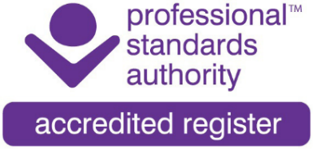

This development provides greater protection to consumers, and we recommend that employers and commissioners of behaviour analytic services such as ABA or PBS use professionals that are listed on the
UK-SBA register and/or make UK-SBA membership a condition of employment to take advantage of the safeguards, PSA accreditation (where applicable) and complaints process should the need occur.

Other exciting news is that behaviour analysts in the UK will now have their own UK based certification. Central to this is values led, person centred supervision, and is in collaboration with UK universities. For BCBAs and equivalent this will be the UKBA(cert), for BCaBAs and equivalent, this will be the aUKBA(cert) and coming soon will be a vocational level qualification.

Below are the current UK-SBA badges for those registered with us as UKBA(cert), a UKBA(cert) and Practising Registrants. Anyone searchable on the UK-SBA register is entitled to use their badge.
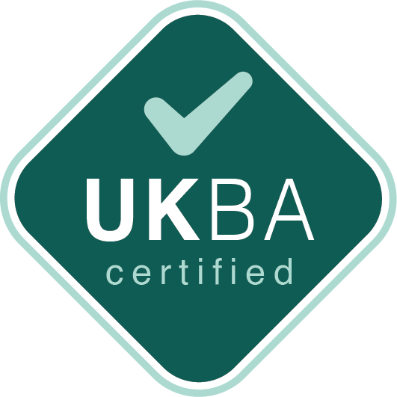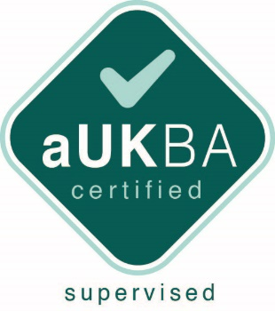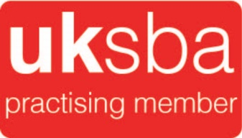

The commonly used term for applications of Behaviour Analysis is Applied Behaviour Analysis (ABA). For those of you that would like an overview of ABA please go to the following link for a short introductory video: This is ABA https://uk-sba.org/this-is-aba/

If you would like further details regarding any of the items in this email, please see the UK-SBA website: https://uk-sba.org

Yours Sincerely,

The UK Society for Behaviour Analysis

